 | 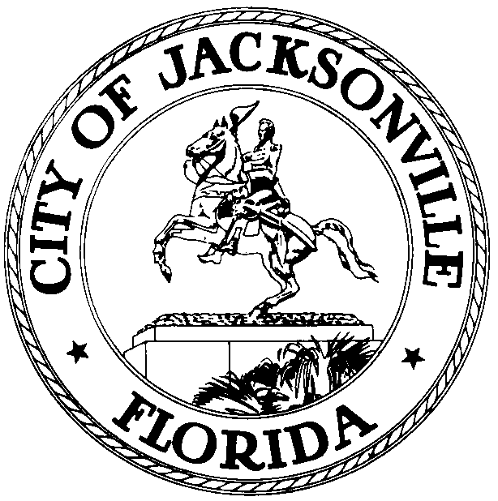
 | OFFICE OF THE CITY COUNCIL
CLAY YARBOROUGH
PRESIDENT |  | SUITE 425, CITY HALL
COUNCIL MEMBER, DISTRICT 1 |  | 117 WEST DUVAL STREET
OFFICE (904) 630-1389 |  | JACKSONVILLE, FLORIDA 32202
FAX (904) 630-2906 |  | E-MAIL: CLAY@COJ.NET

December 5, 2014
11:00 a.m.

MEMORANDUM

TO: Members of Council

FROM: Clay Yarborough, Council President

RE: Special Economic Development Incentives Committee

In accordance with Council Rule 2.103(a), as President of the Jacksonville City Council, I am hereby appointing a Special Economic Development Incentives Committee.

CHARGE: The Special Economic Development Incentives Committee shall be charged with the task of reviewing and analyzing all aspects of the City’s current economic development incentive policies and strategies for the purpose of determining if the policies and procedures currently in the place are adequate to the task of properly and efficient incentivizing the type of economic development activity that the City desires. The committee should review the existing incentive offerings available through the City (Office of Economic Development, Downtown Investment Authority, Community Redevelopment Areas, Tax Increment Districts, Neighborhoods Department, Enterprise Zone, etc.) and the state (Enterprise Florida and other agencies) and determine if the available incentives are appropriate and sufficient to make Jacksonville attractive and competitive in the marketplace for the types of targeted industry sectors and companies that the City desires to grow or relocate to the city. The committee should examine how changes in the city, state and national economies, changes in technology, the evolving workforce, and the nature of work in general in the modern world economy may be changing what local governments need to do to become and remain economically attractive in the marketplace.

The committee is charged to analyze the administration and performance of the City’s current economic development incentives, reviewing the incentives offered and accepted over the past four years and attempting to determine if the companies receiving the incentives are actually producing the new jobs, payroll, capital investment, and tax revenues projected at the time the incentives were granted. The relationship between the City and the JAX USA partnership should be examined to determine if the entities are maximizing their joint efforts and if there are potential improvements that might increase efficiency or overall effectiveness.

MEMBERS:
John Crescimbeni, Chair
Greg Anderson
Matt Schellenberg

DEADLINE – The Economic Development Incentives Committee is tasked to report its findings and
to propose legislation, if necessary, by April 30, 2015.

I appreciate the willingness of the members to devote the necessary attention to this important issue.

cc: Council Members/Staff
Cheryl Brown, Director/Council Secretary
Jeff Clements, Chief, Research Division
Dana Farris, Chief, legislative Services Division
Cityc@coj.net
Electronic Notice Kiosk – 1st Floor City Hall
Public Notice System – City Council Web Page
Media Box

